- CHEF JACKETS S/SLEEVE, L/SLEEVE & CONTRA
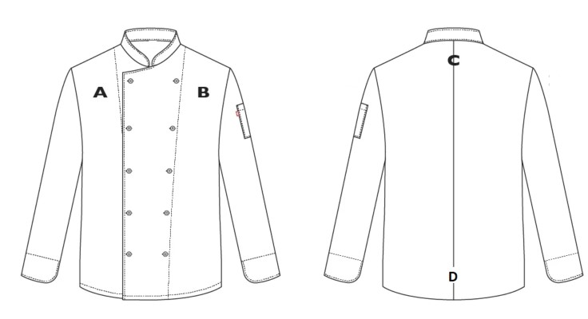 | Size | ½ Chest  [A-B] | Centre Back Length[C-D]
 | XS | 49cm | 70cm
 | S | 52cm | 71cm
 | M | 55cm | 72cm
 | L | 58cm | 74cm
 | XL | 62cm | 76cm
 | 2XL | 66cm | 78cm
 | 3XL | 70cm | 80cm
 | 4XL | 74cm | 82cm
*Size measurements reflect actual sizes of the garments

- CHEF PANTS

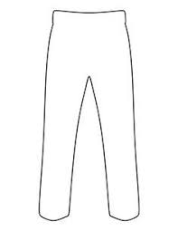 | Size | Elasticated Waist (Relaxed) | Side Length (Waist- Ankle)
 | XS | 72cm | 98cm
 | S | 76cm | 102cm
 | M | 80cm | 104cm
 | L | 84cm | 106cm
 | XL | 88cm | 110cm
 | 2XL | 92cm | 114cm
 | 3XL | 96cm | 118cm
 | 4XL | 100cm | 122cm

- HACCP OVERALL JACKET / CHEF BASIC 2 STUD JACKET
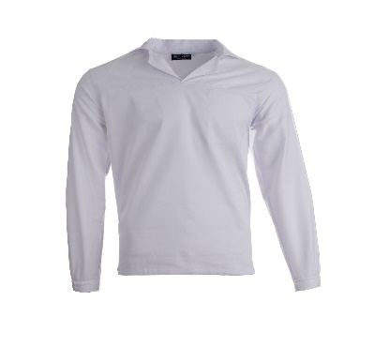 | Size | ½ Chest | Back Length
 | XS | 50cm | 70cm
 | S | 52cm | 71cm
 | M | 55cm | 73cm
 | L | 58cm | 74cm
 | XL | 62cm | 75cm
 | 2XL | 66cm | 77cm
 | 3XL | 70cm | 79cm
 | 4XL | 74cm | 81cm

