* **SCRUB TOPS**

|  |  |  |  |
| --- | --- | --- | --- |
|  | **Size** | **½ Chest** | **Back Length** |
| **XS** | 46cm | 64cm |
| **S** | 50cm | 68cm |
| **M** | 54cm | 70cm |
| **L** | 58cm | 74cm |
| **XL** | 62cm | 78cm |
| **2XL** | 66cm | 80cm |
| **3XL** | 70cm | 84cm |
| **4XL** | 74cm | 86cm |

* **SCRUB PANTS**

|  |  |  |  |
| --- | --- | --- | --- |
|  | **Size** | **Elasticated Waist (Relaxed)** | **Side Length (Waist- Ankle)** |
| **XS** | 72cm | 98cm |
| **S** | 76cm | 102cm |
| **M** | 80cm | 104cm |
| **L** | 84cm | 106cm |
| **XL** | 88cm | 110cm |
| **2XL** | 92cm | 114cm |
| **3XL** | 96cm | 118cm |
| **4XL** | 100cm | 122cm |

* 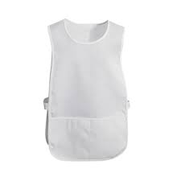**PINAFORES**

|  |  |  |  |
| --- | --- | --- | --- |
| **Size** | **½ Chest** | **Back Length** | **Before Curve** |
| **S/M** | 42cm | 78cm | 45cm |
| **L/XL** | 46cm | 78cm | 51cm |