- 2PC OVERALLS
Size | Jacket Sizes | ½ Chest | Waist
XS | 32 | 48,5cm | 62-72
S | 34 | 51cm | 67-77
S | 36 | 53,5cm | 72-82
M | 38 | 56cm | 77-87
M | 40 | 58,5cm | 82-92
L | 42 | 61cm | 87-97
L | 44 | 63,5cm | 92-102
XL | 46 | 66cm | 97-107
2XL | 48 | 68,5cm | 102-112
3XL | 50 | 71cm | 107-117
3XL | 52 | 73,5cm | 112-122
4XL | 54 | 76cm | 117-127
4XL | 56 | 78,5cm | 122-132
5XL | 58 | 81cm | 127-137

- DUSTCOATS
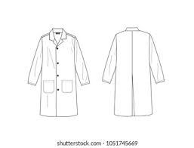 | Size | ½ Chest | Back Length
 | XS | 54cm | 90cm
 | S | 56cm | 92cm
 | M | 58cm | 94cm
 | L | 60cm | 96cm
 | XL | 64cm | 98cm
 | 2XL | 68cm | 100cm
 | 3XL | 70cm | 102cm
 | 4XL | 72cm | 104cm

